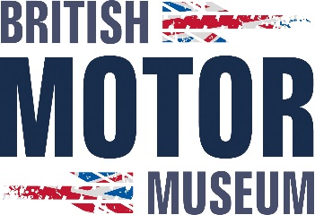

Job Description

Job Title: | Casual Grounds Person
Salary: | £12.71 per hour
Contract Type: | Casual – 2 days per week
Reporting to: | A Bruneau

Job Purpose
This is an exciting opportunity to work at the British Motor Museum, Gaydon, home to the world’s largest collection of British motor vehicles.
To play an active role in helping to maintain our extensive grounds by working alongside the Grounds Person on a casual, two-day-per-week basis. This hands-on role is perfect for someone who takes pride in high standards, enjoys varied outdoor work, and brings strong attention to detail to everything they do. Every day is different, and an adaptable, can do attitude along with a commitment to safe working practices is essential to keeping our grounds welcoming and well presented for all visitors.

If you’re ready to make a visible impact in a unique heritage setting and enjoy working outdoors as part of a supportive team, we’d love to hear from you

Main Duties
Assisting the current Grounds person with;
- Mowing of all grassed areas
- Pruning of trees and hedges
- Strimming on site as required
- Tree care
- Maintaining all external seating and tables
- Gritting of the site during the winter months
- Undertaking site set ups to support the summer shows season
- Deployment of barriers and signs as required to support daily business requirements

Knowledge, Skills, Experience and Attributes Required

- Good communication skills
- Smart appearance
- Eager to learn new skills
- Able to work as part of a team as well as on own initiative
- Able to work outside in all weathers
- Computer literate
- Awareness of health and safety
- Full UK Driving Licence (preferable due to location of workplace)

Inclusion and Diversity Statement

As an organisation the British Motor Industry Heritage Trust is committed to eliminating discrimination and encouraging diversity amongst our workforce. We welcome applications from suitably qualified and eligible candidates regardless of sex, race, disability, age, sexual orientation, gender reassignment, religion or belief, marital status, or pregnancy and maternity.
Applications
Please send a CV and covering letter to: hr@britishmotormuseum.co.uk
Applications must be received on or before the closing date.
Closing Date: Midday, 3 July 2026

